Cheerleading Poetry
Kristen Zilkofski
Kane Area School District
Kane Area School District
Acrostic:
Cheerleading
Chants and Cheers
Happy faces
Excitement
Experience
Round Offs
Landing Jumps
Eating Healthy
Apples are best
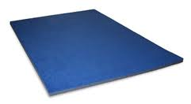
Down the Mat we go!
Alliteration:
Mat
Madie mounts on the mat
Madie misses Morgan’s foot
Mat caught Morgan
Madie and Morgan make it in the air

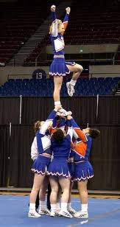
Cinquain:
Flyer
Lightweight, Balanced
Bouncing, Pushing Off, Soaring
Excited to soar high
Stunter
Haiku:
Toe Touch
Jump high in the sky
Point your toes to win a prize
Trophy here we come

Tanka:
Louder
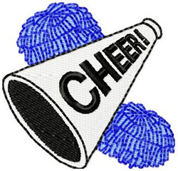
Through the goal yell ready
Louder, louder go big blue
Pushups down we go
Get back up another cheer we need
At the end we win hooray!
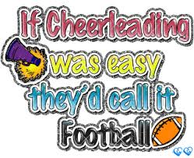
Limerick:
Their cheers were very loud
They stood tall and proud
They had spirit to spare
Their cheer had a flare
They even stirred the crowd

Onomatopoeia:
The players run down the court
The cheerleaders scream wahoo!
Buzz!
The buzzer beeps time for the quarter cheer
Harrah, Harrah! Time is up
Back to their seats with a crack
Oh No Brooke falls with a smack

Five Senses:
Pom-Poms look fuzzy to me
They taste like plastic
Pom-Poms sound like maracas
They smell like rubber and hand sweat
They really look fringy and shiny
Pom-Poms make me feel like I’m a real cheerleader
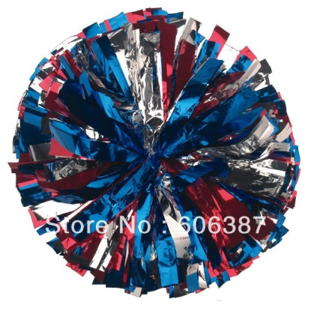

Ode:
Bases oh my bases
Lift me from the floor to the sky
Maybe you drop me
But you catch me ever so high
When you release me into thin air
Flowing is my hair
Always so strong and tough
Get me to soar through the sky
Two years together
In my heart forever
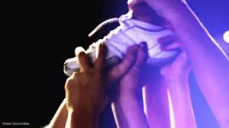

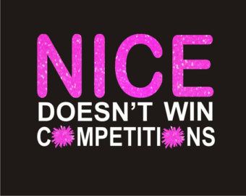
Quatrain:
Competing is a blast
Practicing longer every night
Routines are ever so fast
And the flyers at great height

